Creating new task – can enter invalid mapping combo, receive error upon create

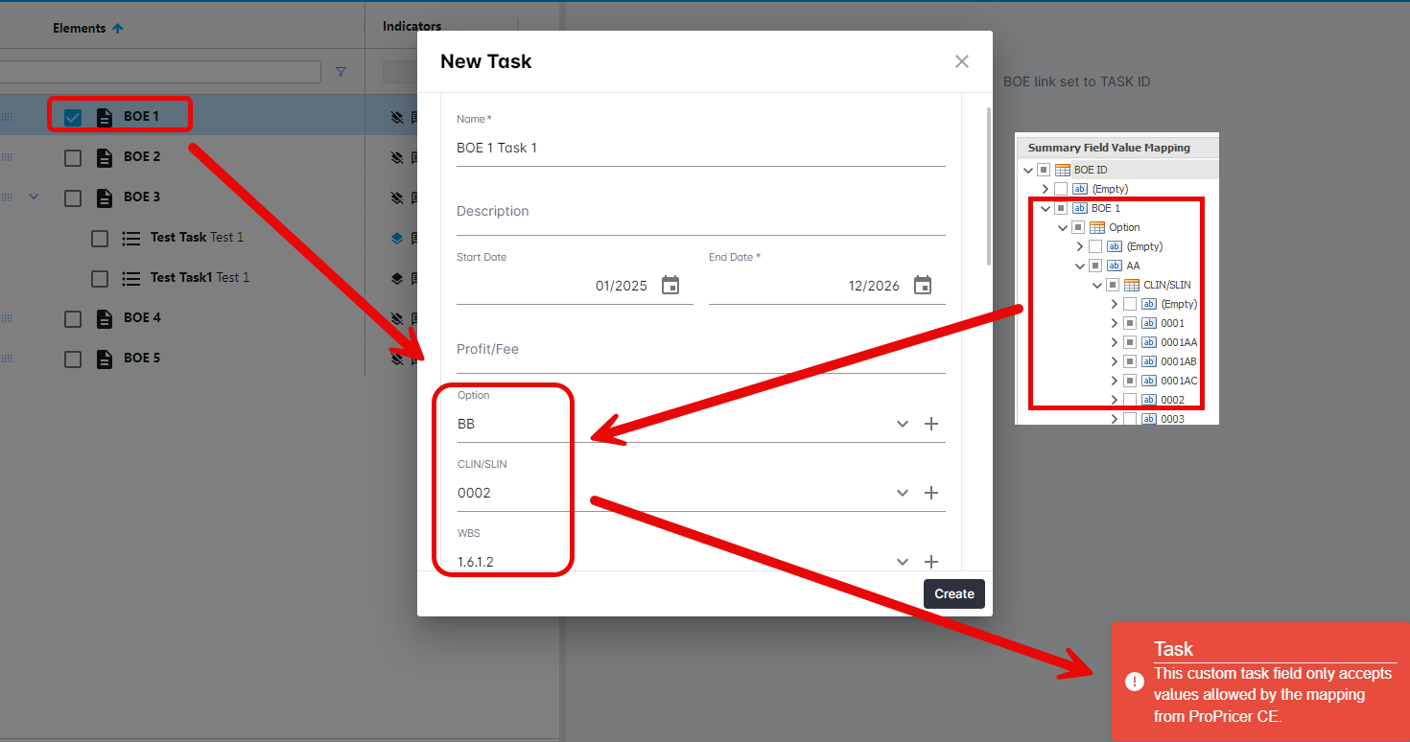

Edit Task – can still enter invalid mapping combo, but receives error symbols that the combo is incorrect prior to hitting the create button.

